# IST 722 Final Project ETL – Group 4

Andrew Zelazny

Charlie Vanleuvan

Connor Gendron

Ryan Fisher

This SSIS package creates the DimDate, DimCustomers, and DimProducts dimension tables in the data warehouse. It also pulls in Orders and OrderDetails from Fudgemart, and AccountBilling from Fudgeflix to combine them into FF_FM_FactSales. The FactSales table can be used to track revenue over time, by product and customer. This enables rich business analytics to be performed to gain insight into Fudgemart’s and Fudgeflix’s revenue streams.

# Full Package

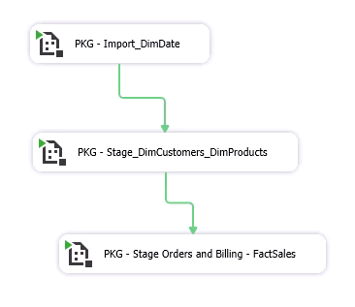

## Import DimDate

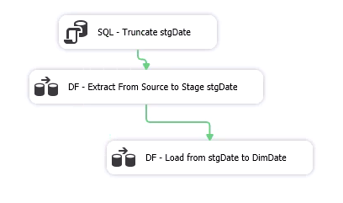

### Source to Stage for DimDate

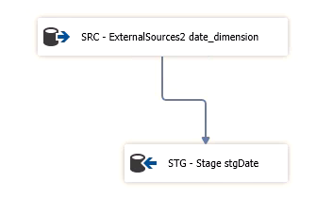

### Stage to DimDate with Slowly Changing Dimension

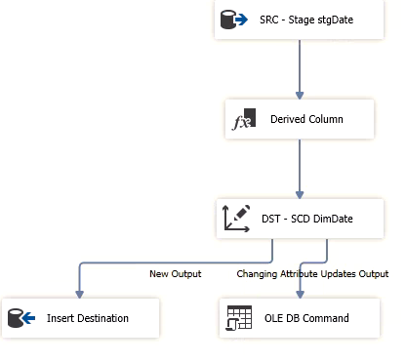

### Derived Columns

The DayOfYear and Year variables were converted to smallint equivalents with derived columns.

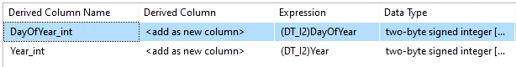

### Source to target mapping in Slowly Changing Dimension:

DateKey is the only Business key. All other dimensions set to Changing Attributes.

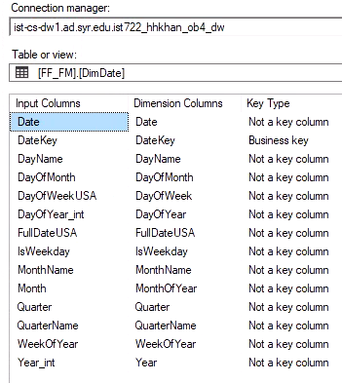 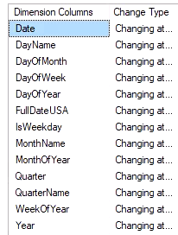

# Stage DimCustomers and DimProducts

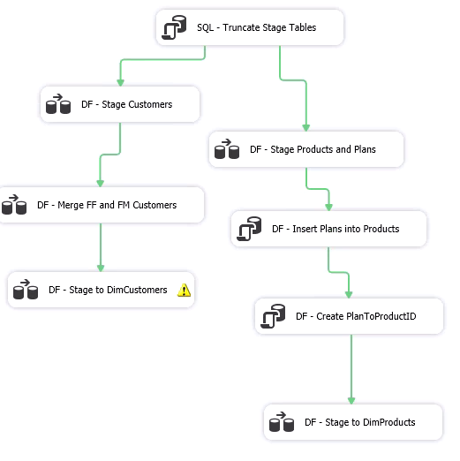

## Import Fudgeflix Customers and Fudgemart Customers from Source:

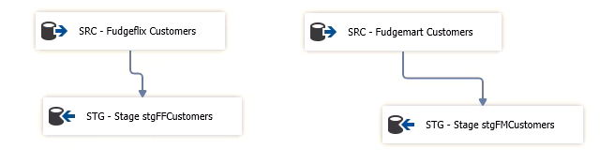

## Merge stgFMCustomers and stgFFCustomers

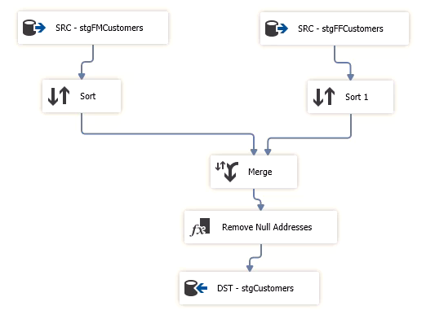

### Merge Columns

Customer databases merged based on id’s, email, names, and address.

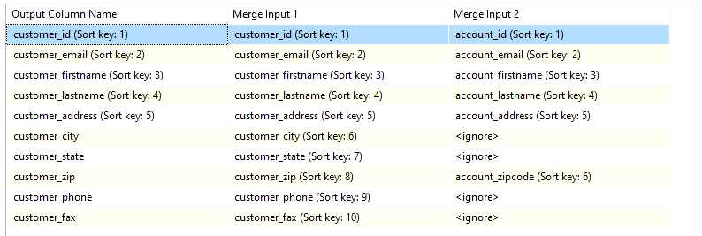

### Derived Column: Remove NULL Addresses



## Stage to DimCustomers

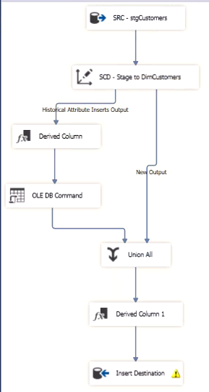

The warning on the Insert Destination is due to a potential to overflow the Zipcode dimension. This should be corrected in the future by converting the Zipcode to a string to allow for non-US zip codes.

### Slowly Changing Dimension:

Customer_id used as the only Business key. All other dimensions set as historical attributes.

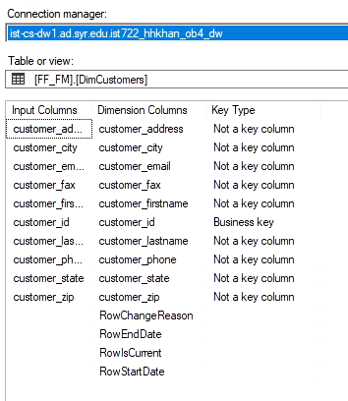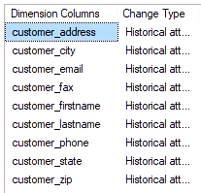

### Preview of DimCustomers

61 rows in DimCustomers in the data warehouse.

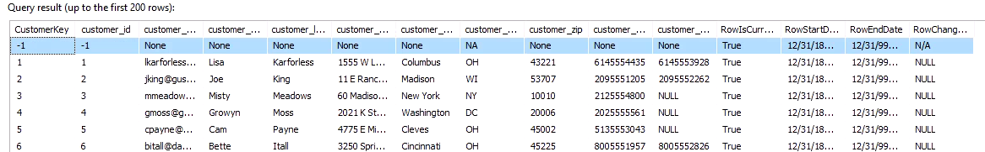

## Import Fudgemart Products and Fudgeflix Plans

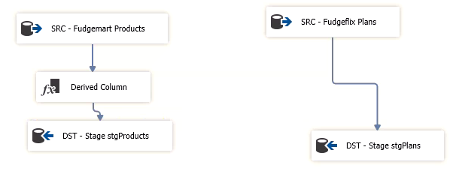

Add plan_id column to stgProducts, all NULL.



## Insert Fudgeflix Plans into stgProducts

Custom written insert statement to add Fudgeflix Plans to stgProducts

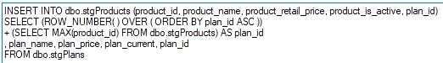

## Create stgPlanToProductID

Custom SQL query to create stgPlanToProductID table for mapping Fudgeflix billing data to conformed DimProducts:

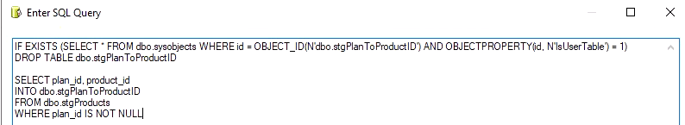

## Stage to DimProducts with Slowly Changing Dimension

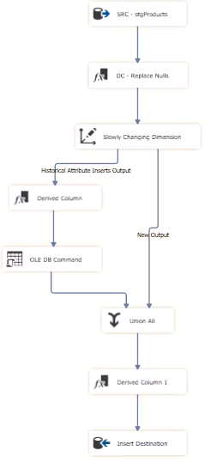

### Replace Null values before deploying to DimProducts

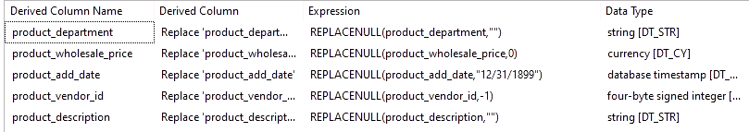

### Slowly Changing Dimension

Product_id set as Business key, other dimensions set to Historical attributes.

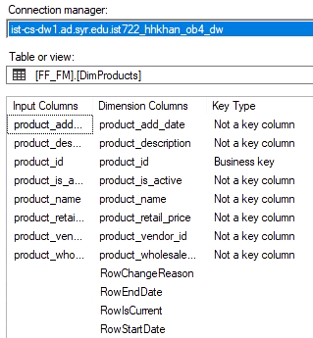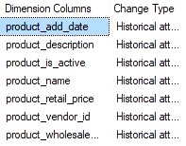

### Preview with Fudgeflix Plans added to the end of DimProducts

61 rows in DimProducts in the data warehouse.

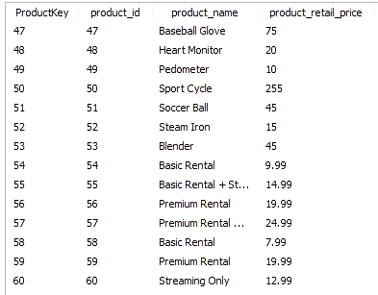

# Import Fudgeflix Account Billing and Fudgemart Orders and OrderDetails

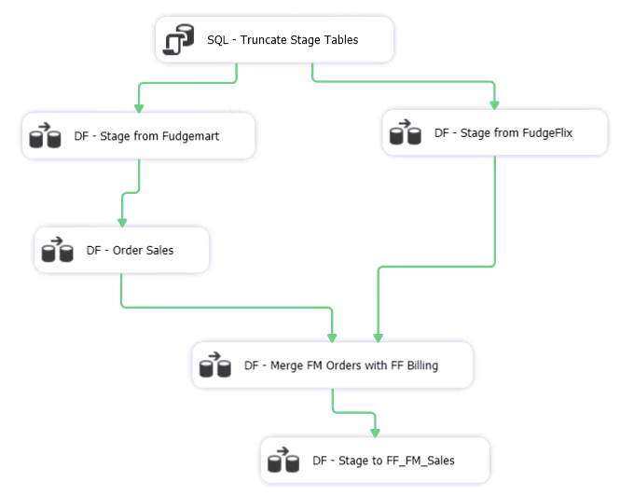

## Import Orders and OrderDetails from Fudgemart to Stage

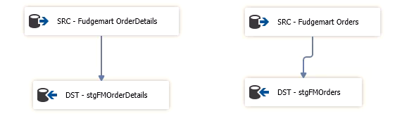

## Merge stgFMOrderDetails and stgFMOrders on order_id

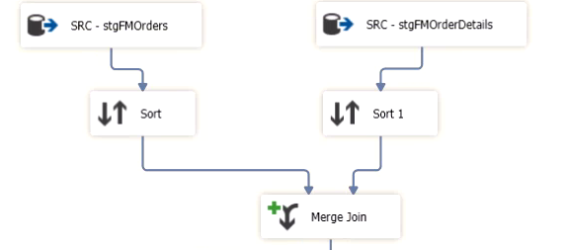

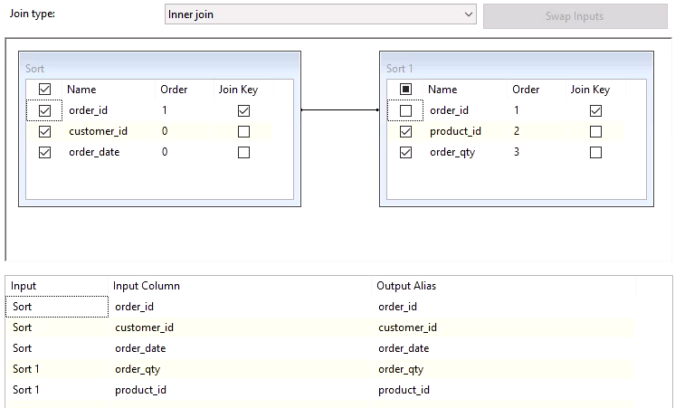

## Pipeline to build stgOrders columns required for FF_FM_FactSales

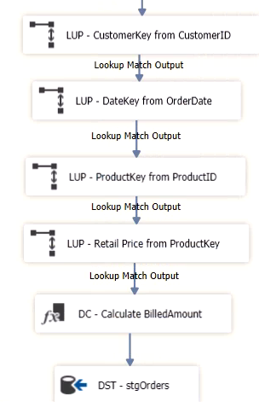

### BilledAmount calculated from order_qty and retail_price



## Import Fudgeflix Account Billing

Apply pipeline to map source to target columns for FF_FM_FactSales.

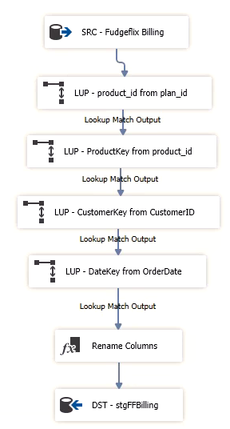

### Rename Columns

Rename columns to match FF_FM_FactSales columns

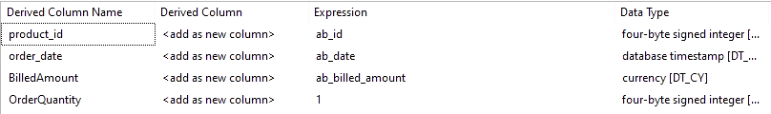

## Merge stgOrders and stgFFBilling

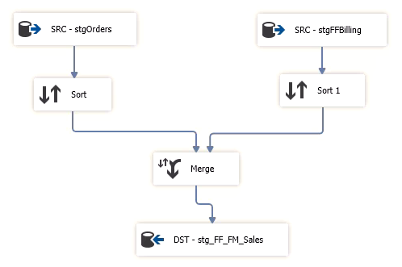

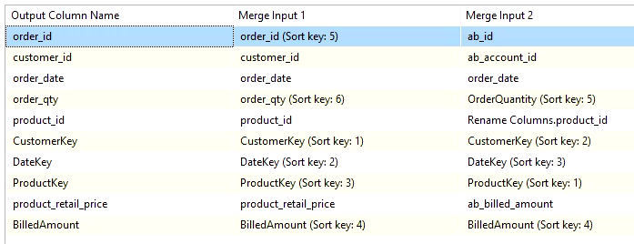

## Stage to FF_FM_FactSales with Slowly Changing Dimension

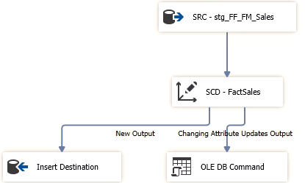

CustomerKey, ProductKey, DateKey, and order_id set as business keys. Order_qty and BilledAmount set as Changing Attributes.

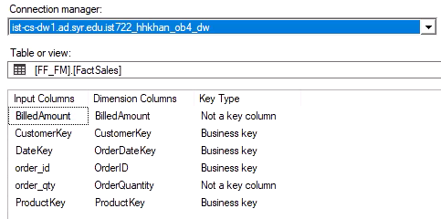 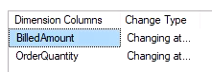

### Preview of Results in FF_FM_FactSales

11,760 rows in FF_FM_FactSales in the data warehouse. This is equal to the sum of the rows in fudgemart_v3.dbo.[fm_order_details], 10,466, and fudgeflix_v3.dbo.[ff_account_billing], 1,294.

